1)how to create the linux vm
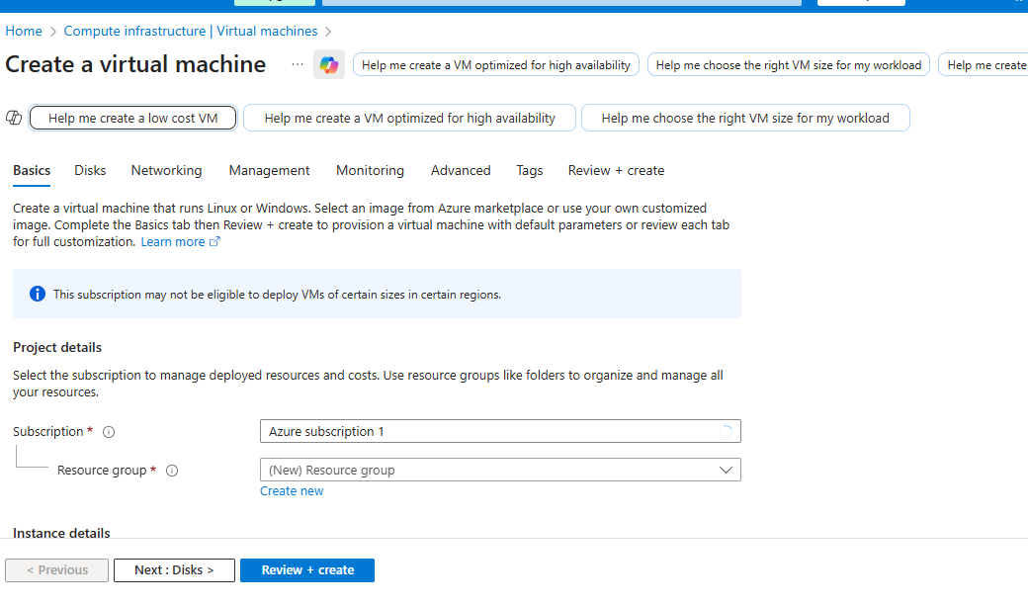
No AZ.needed
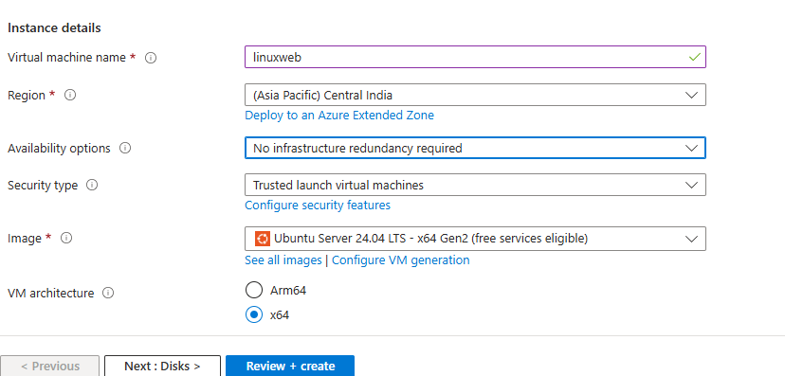
Basix size and access via ssh.
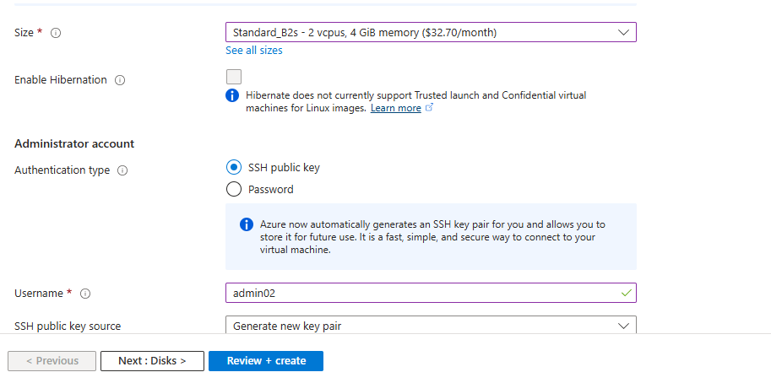
Creta new v-net and nubnet and public ip
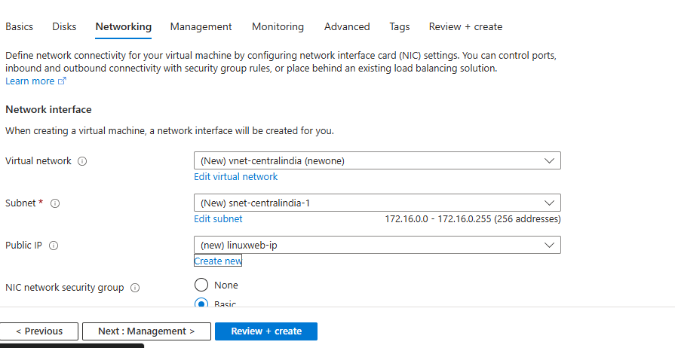

Download the private key ,inside the vm there is public key and u will have private key.
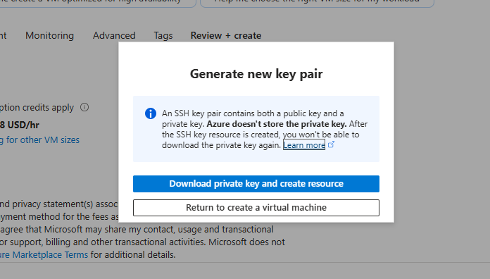

✅ How SSH Key Works (Private Key + Public Key)
When you create a VM using SSH authentication:

1️⃣ Your computer generates two keys
- Private Key (id_rsa) → stays with YOU
- Public Key (id_rsa.pub) → goes INSIDE the VM
These two keys are mathematically linked.

🤝 4️⃣ What actually happens during SSH login?

🔸 Step A — VM checks if your PUBLIC key exists in authorized_keys file
If found → VM says, “Okay, let’s verify you!”

🔸 Step B — VM sends you a challenge (encrypted with your public key)

🔸 Step C — Your laptop uses PRIVATE key to decrypt the challenge
If it decrypts correctly:
➡️ You are authenticated
➡️ VM allows SSH login
If you don’t have the correct private key → login fails.

The key will get download in the window download section.
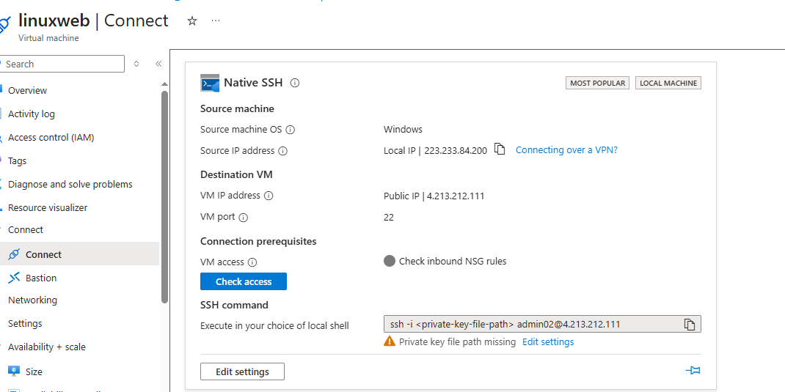
GO TO THE CMD :-GO TO THE DOWNLOAD WHERE ARE KEY IS.
cd C:\Users\Admin\Downloads
PASTE THE SSH COMMAND :- NOW U ARE IN LINUX.
2) IF U WANT TO HOST THE WEB SITE IN IT FIRST GO T THE NETWORK SETTING AND ADD HTTP PORT 80.

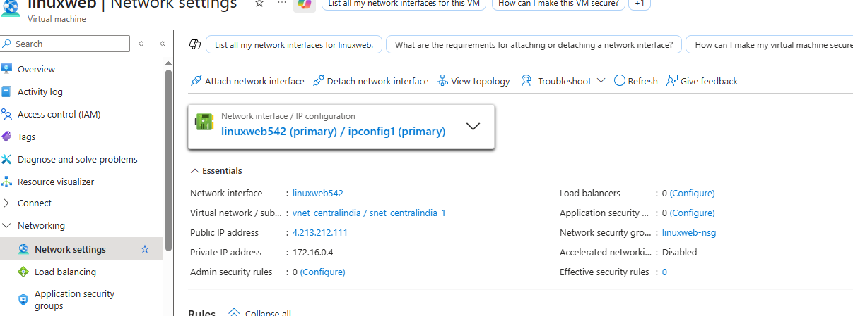

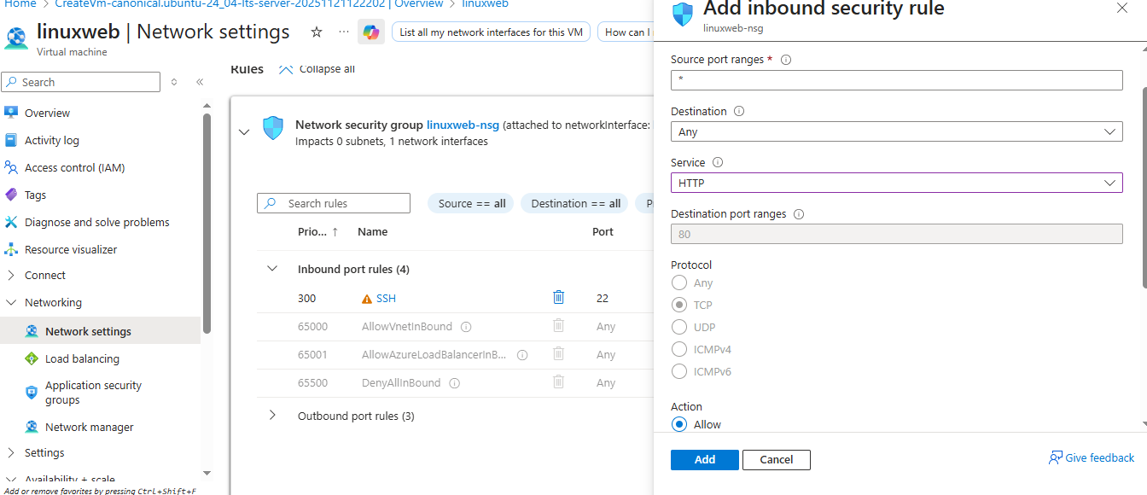
AFTER THIS GO TO CMD:-
sudo apt install apache2 -y
sudo systemctl start apache2
sudo systemctl enable apache2
systemctl status apache2

NOW GO TO THE BROWSER AND ADD HTTP://IP
U WILL SEE DEDAULT PAGE.
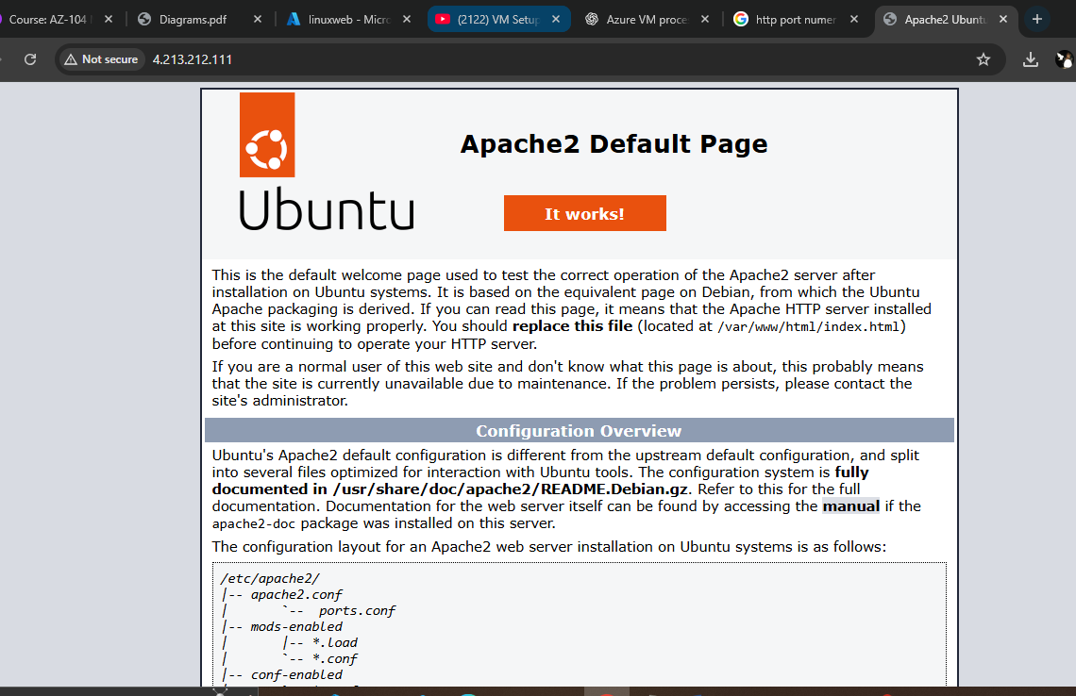
IF U WANT TO HOST YOUR WEBSITE SEE BELOW COMMANDS.

🟦 Where to put your website?
Place your files in:
/var/www/html/
Example:
sudo nano /var/www/html/index.html
Write something:
<h1>Hello from my Ubuntu web server!</h1>.

3)IF U WANT TO USE AZURE TERMINAL GO TO CREATED VM-HELP-serial console.

IF U WANT TO ACCESS LINUX ON MAC DO THE NAME.

4)CREATE LINUX VM USING PASSWORD.
WHEN CREATING THE VM ADD USERNAME AND PASSWORD.
AND GIVE THAT USERNAME,PASSWORD AND PUBLIC IP TO USER.
FOR THIS LINUX WILL GIVE U SSH COMAND U JUST HAVE TO ADD THAT :
SSH USERNAME@IP
THEN IT WILL ASKED U PASSWORD THEN ADD THAT.

